37.35: a) Your total energy E increases because your potential energy increases;
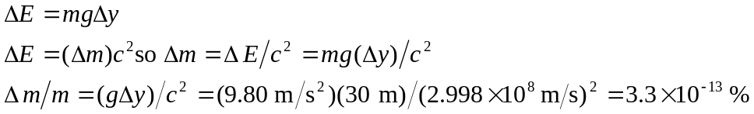
This increase is much, much too small to be noticed.
b)
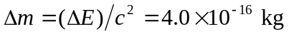
Energy increases so mass increases. The mass increase is much, much too small to be noticed.

